Cryptography Midterm Exam II 2008/06/02

Part I (3 points each)

1. For RSA modulus N = 10403 = 101×103, which can NOT be a public exponent e?
A. 11 B. 13 C. 17 D. 19 E. None of the above

2. Apply Fermat’s primality test on 21. Which is NOT a witness of compositeness?
A. 2 B. 4 C. 5 D. 8 E. None of the above

3. What is the output length (in bits) of the hash function SHA-1?
A. 128 B. 144 C. 160 D. 192 E. None of the above

4. The branch number in the case of MixColumn operation of AES is defined by min_{a≠0}(W(a)+W(F(a)), where a is a 4-byte vector, F is a linear transformation, and W is the weight function. What is the maximal branch number?
A. 5 B. 6 C. 7 D. 8 E. None of the above

5. Apply the Miller-Rabin test t times to an odd composite number. Which is the best estimate of the probability of finding at least one witness of compositeness?
A. (½)^{t} B. (¾)^{t} C. 1 − (¾)^{t} D. 1 − (½)^{t} E. 1 − (¼)^{t}
6. Which item is definitely NOT listed on a certificate? A. Public key
B. Private key C. User name D. Expiry date E. None of the above

7. Which statement is FALSE about PKI?
A. SSL aims to provide channel security to fulfill commercial requirement
B. X509 defines a structure for public key certificates
C. CA establishes the identity of users, but does not sign certificates
D. CRL is a list of the serial numbers of all the revoked certificates
E. None of the above

8. Which statement is FALSE about Merkle-Damgård construction of hash functions?
A. Use a collision-resistant compression function f with arbitrary length of input
B. Add a single one bit to signal the end of a message, then pad with zeros
C. The final block encodes the original length of the unpadded message in bits
D. The internal state H := f (H || m_{i} ) is updated repeatedly with message block m_{i}
E. None of the above
9. Which property is NOT provided by digital signature schemes?
A. Message confidentiality B. Message Authentication
C. Message integrity D. Non-repudiation E. None of the above

10. A cryptographic hash function should satisfy these three assumptions:
(a) Pre-image Resistant − Given y, hard to find x such that h(x) = y
(b) Collision Resistant − Hard to find any x ≠ x′ such that h(x) = h(x′)
(c) Second Pre-image Resistant − Given h(x), hard to find x′ (≠ x) with h(x) = h(x′)
Denote “M > N” as “M is a stronger assumption than N”. Which relation is correct?
A. (c) > (b) > (a) B. (b) > (a) > (c) C. (a) > (c) > (b)
D. (c) > (a) > (b) E. None of the above

Part II (3 points each)

• Represent F₁₆ by polynomial representations with the irreducible f(x) = x⁴ + x + 1. Choosing g = (0010) as a generator for F₁₆, we list all elements of F₁₆ as follows.

0 = (0000) g⁰ = (0001) g¹ = (0010) g² = (0100)
g³ = (1000) g⁴ = (0011) g⁵ = (0110) g⁶ = (1100)
g⁷ = (1011) g⁸ = (0101) g⁹ = (1010) g¹⁰ = (0111)
g¹¹ = (1110) g¹² = (1111) g¹³ = (1101) g¹⁴ = (1001)

Consider the elliptic curve group G defined by y² + xy = x³ + g⁴ x² + 1 over F₁₆ . There are 15 points satisfying the equation as the graph.
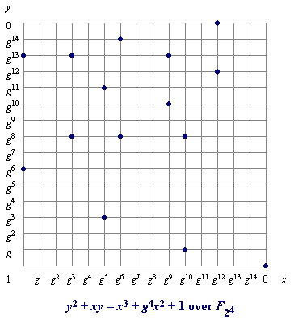
Let P = (1, g⁶) and Q = ( g⁵, g¹¹).

■ The group order | G | = 11 .
■ P + Q = 12 .
■ – Q = 13 .
■ 2P = 14 .
■ 4P = 15 .

The formulas in Part III might help
your computations.

• Factor n = 87463 with the Quadratic Sieve. Define g(x) = x² − n.
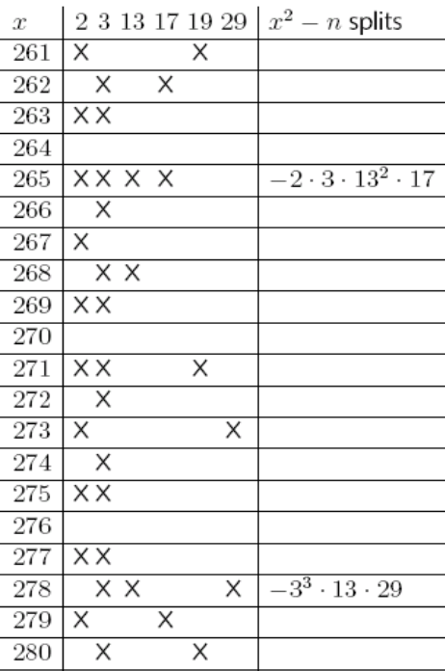
x | −1 | 2 | 3 | 13 | 17 | 19 | 29
265 | 1 | 1 | 1 | 0 | 1 | 0 | 0
278 | 1 | 0 | 1 | 1 | 0 | 0 | 1
296 | 0 | 0 | 0 | 0 | 1 | 0 | 0
299 | 0 | 1 | 1 | 0 | 1 | 1 | 0
307 | 0 | 1 | 0 | 1 | 0 | 0 | 1
316 | 0 | 0 | 0 | 0 | 1 | 0 | 0

The integers x₁, x₂, and b satisfy
g(265) × g(278) × g(x₁) × g(x₂) ≡ b² (mod n).

■ If 0 < x₁ < x₂ , then x₂ = 16 .
■ If 0 < b < n, then b = 17 .
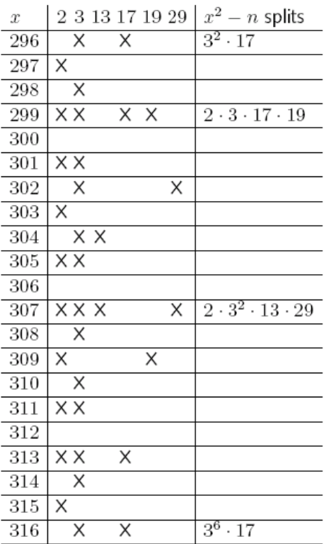
■ If a ≡ 265 × 278 × x₁ × x₂ (mod n)
and 0 < a < n, then a = 18 .
■ If n = p × q and 0 < p < q,
then p = 19 and q = 20 .

These congruences might reduce your computational effort:
265 × 307 = 81355 ≡ −6108 (mod n)
265 × 316 = 83740 ≡ −3723 (mod n)
278 × 296 = 82288 ≡ −5175 (mod n)
278 × 299 = 83122 ≡ −4341 (mod n)
3⁵ × 13 × 17 × 29 ≡ −16947 (mod n)
3⁴ × 13² × 17 × 29 ≡ 14026 (mod n)

• The solution to the system of congruences
2x ≡ 3 (mod 7) 3x ≡ 6 (mod 11) 4x ≡ 10 (mod 13)
is x ≡ 21 (mod 22 )

• Consider the RSA signature scheme with the public key n = 85 and e = 3.
■ The private key for signing is d = 23 .
■ Signing the message m = 4, a user obtains its digital signature s = 24 .
• In a Diffie-Hellman key exchange scheme on Z₃₁ with the generator g = 3, Alice chooses 9 and Bob chooses 7 in private. Then Alice sends 25 to Bob, and the agreed key is 26 .

• Decrypting the ciphertext c = 39 of the Rabin public-key cryptosystem c = m × (m + 10) (mod 187), a user obtains four possible corresponding plaintexts m = 3, 20, 27 , and 28 (in increasing order).

• If a message m is divided into t blocks m₁, m₂, …, m_{t} , then the CBC-MAC with a cipher e and a key k is derived by the process I₁ = m₁, O₁ = e_{k}(I₁), I_{i} = m_{i} ⊕ 29 , and O_{i} = 30 for i = 2, 3, …, t.

Part III (Write down all details of your work)

31 (5 points)
Derive arithmetic formulas of elliptic curve groups defined by y² + xy = x³ + ax² + b with b ≠ 0 over F₂ m.
- P₁ = (x₁, y₁) and P₂ = (x₂, y₂) are two distinct points on the curve with P₁ ≠ − P₂.
If (x₃, y₃) = P₁ + P₂ and s = (y₁ + y₂) / (x₁ + x₂), show that x₃ = s² + s + x₁ + x₂ + a
and y₃ = s (x₁ + x₃) + x₃ + y₁.
- P₀ = (x₀, y₀) is a point on the curve with x₀ ≠ 0. If (x₄, y₄) = 2P, show that
x₄ = x₀² + (b/ x₀²) and y₄ = x₀² + x₄ (y₀ / x₀ + x₀ + 1).

32 (5 points)
As the MixColumn operation of AES, we work on polynomials of degree 3 over F₂₅₆.
Let a(x) = a₃(x + 1)³ + a₂(x + 1)² + a₁(x + 1) + a₀ and
b(x) = b₃(x + 1)³ + b₂(x + 1)² + b₁(x + 1) + b₀ be two polynomials with a_{i} , b_{i} in F₂₅₆.
- If a(x) b(x) ≡ 1 (mod (x⁴ + 1)), show that
(i) b₀ = a₀⁻¹
(ii) b₁ = a₁ b₀ a₀⁻¹
(Also b₂ = ( a₂ b₀ + a₁b₁ ) a₀⁻¹ and b₃ = ( a₃ b₀ + a₂ b₁ + a₁b₂ ) a₀⁻¹, but you do not have to show them.)
- Find all self-inverse polynomials. That is, indicate the conditions on a(x) such that a(x)² ≡ 1 (mod (x⁴ + 1)). Prove your claim.

Cryptography Midterm Exam II 2008/06/02
Name: ____________ Student ID number: ____________

1 | 2 | 3 | 4 | 5 | 6 | 7 | 8 | 9 | 10
11 |  | 12 |  | 13 |  | 14 |  | 15
16 |  | 17 |  | 18 |  | 19 |  | 20
21 |  | 22 |  | 23 |  | 24 |  | 25
26 |  | 27 |  | 28 |  | 29 |  | 30

31 32
Cryptography Midterm Exam II 2008/06/02
Solution
1 | 2 | 3 | 4 | 5 | 6 | 7 | 8 | 9 | 10
C | D | C | A | E | B | C | A | A | E
11 |  | 12 |  | 13 |  | 14 |  | 15
16 |  | (g¹⁰, g⁸) |  | (g⁵, g³) |  | (0, 1) |  | O (Infinity)
16 |  | 17 |  | 18 |  | 19 |  | 20
307 (316) |  | 28052(77542) |  | 34757(9921) |  | 149 |  | 587
21 |  | 22 |  | 23 |  | 24 |  | 25
607 |  | 1001 |  | 43 |  | 64 |  | 29
26 |  | 27 |  | 28 |  | 29 |  | 30
27 |  | 157 |  | 174 |  | O_{i−1} |  | e_{k}(I_{i})

32
(b) a(x) = a₃(x + 1)³ + a₂(x + 1)² + 1 with a₃ , a₂ in F₂₅₆,
or a(x) = b₃ x ³ + b₂ x ² + b₃ x + (b₂ + 1) with b₃ , b₂ in F₂₅₆.

